Meat Industry Pallet Pilot Project
Carton size and pallet configuration information collection form
This information collection form needs to be completed for each different establishment number, carton size and pallet configuration that enters your establishment.
For information about the pallet pilot project please contact Leonard Lang 540-848-5384.
Please email the competed form and any photos to info@meatmessaging.com

Details about completion
Completed at: _________________________________________________________________________
Completed by: _______________________ Date completed: ________________________

Carton details
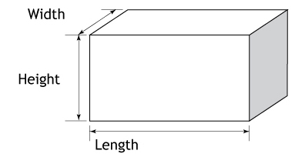
Country: ______________________ Establishment Number: ______________________
Width: _______________________
Height: _______________________
Length: _______________________
Please supply a photo of the carton end panel and a close up of the carton label.
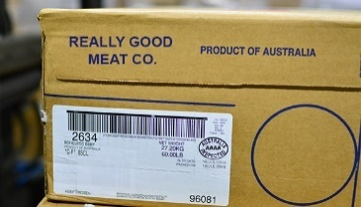
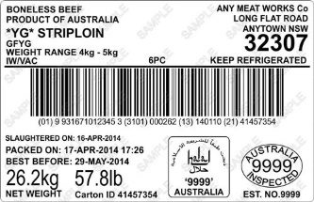
Carton Carton
End Label
Panel

Pallet details
If the cartons arrive on a pallet what was the pallet configuration: _______________ and count: _________
When the cartons leave on a pallet what was the pallet configuration: _____________ and count: ____________
Use the examples below as a guide:
